DOCUMENTATION ALONG WITH PROCESS AND FEATURES

DocSort is an application used to read the number of documents such as files in the format of like pdf, jpg, png, bmp, doc, docx. This section explains the features available in the home screen of DocSort . These areas include the Tree view.

The following screen is Login screen of the Application.

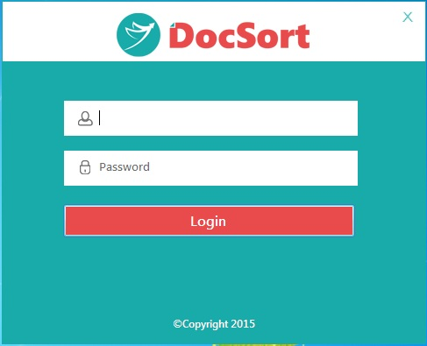

After login into application will moved to Home Screen which includes all the features of application. Below screen represents Home Screen…

Search Docs:
In the below Screen, you can enter Type Of Search Strings and Type Of Docs in comma(,) separated. Here basically creates Main folder with the matched search string. If Type of Docs is given and also if that Doc is having any one of given Type, then Doc will move into main folder which creates with the matched search string and of course subfolder will creates with the having Type and that particular file will move into the subfolder. If Type of Docs is not given then main folder which creates with the matched search string and the file will move into the main folder itself it does not have any subfolder. You can also Browse the folder from where you have files that is Files From and to where you want to move files that is Files To. Also you have Move UnMatch Files To Error means the docs which are not read. You have Start button, once you click on this files will move from Source folder to Destination folder and you will get Cancel button is to cancel the process. You can also import Search string values from Excel sheet. By default these files will move into Default File Cabinet, if you want to move into other File cabinet you have an option to create your own file cabinet after that please the particular cabinet to which you want to move files for this you have to check checkbox By default files will be moved to default cabinet, if not please check to choose cabinet to move.

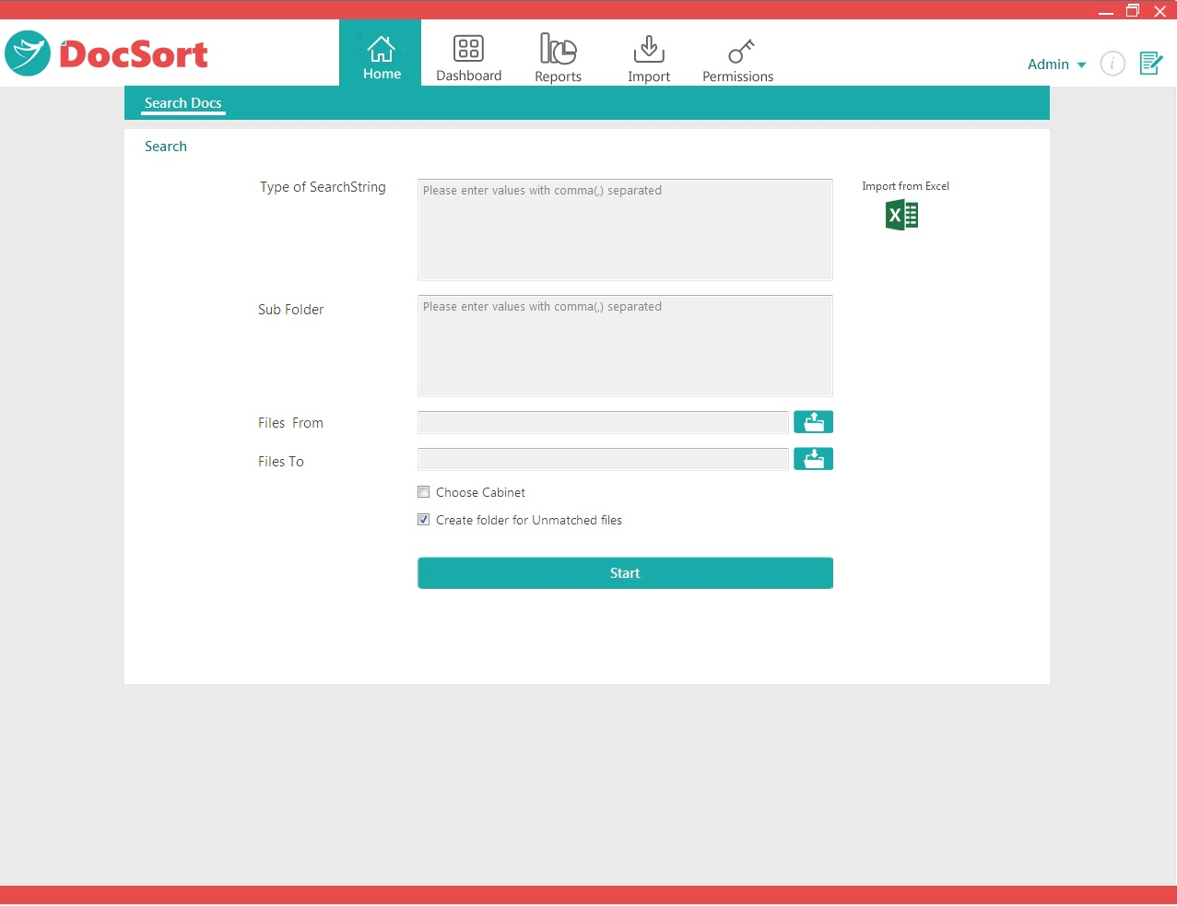

Let us make discussion on Dashboard Menu which includes the following features..
- Dashboard
- New
- Open
Dashboard:
It is the page in which you can find all cabinets which are created from New page. Here is the page.
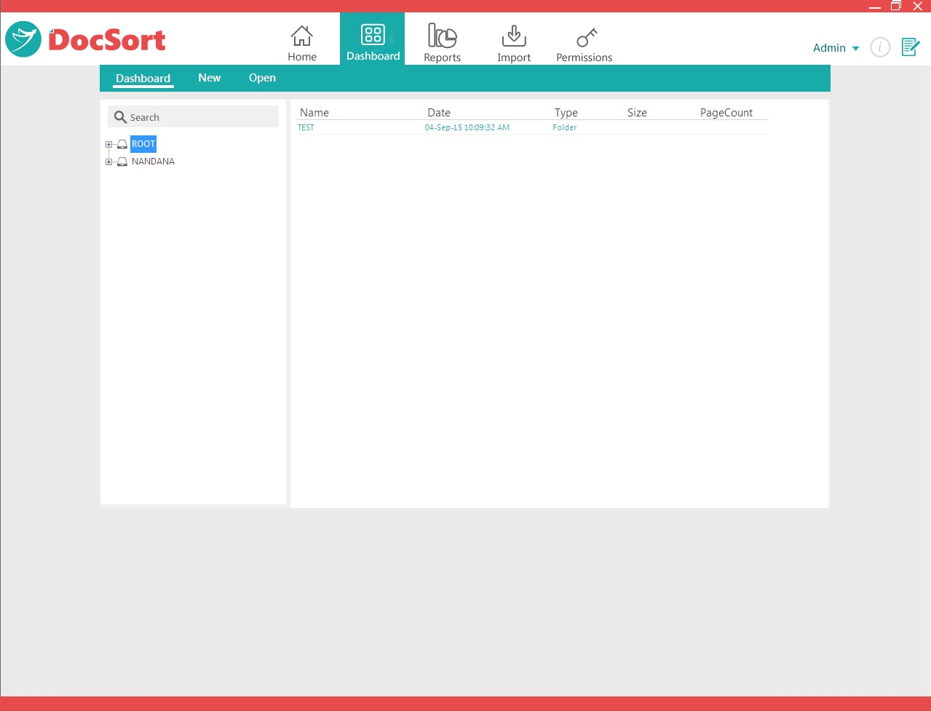
You can see which type of folders or files are present in selected cabinet. You can also view the documents which are present in corresponding cabinets.
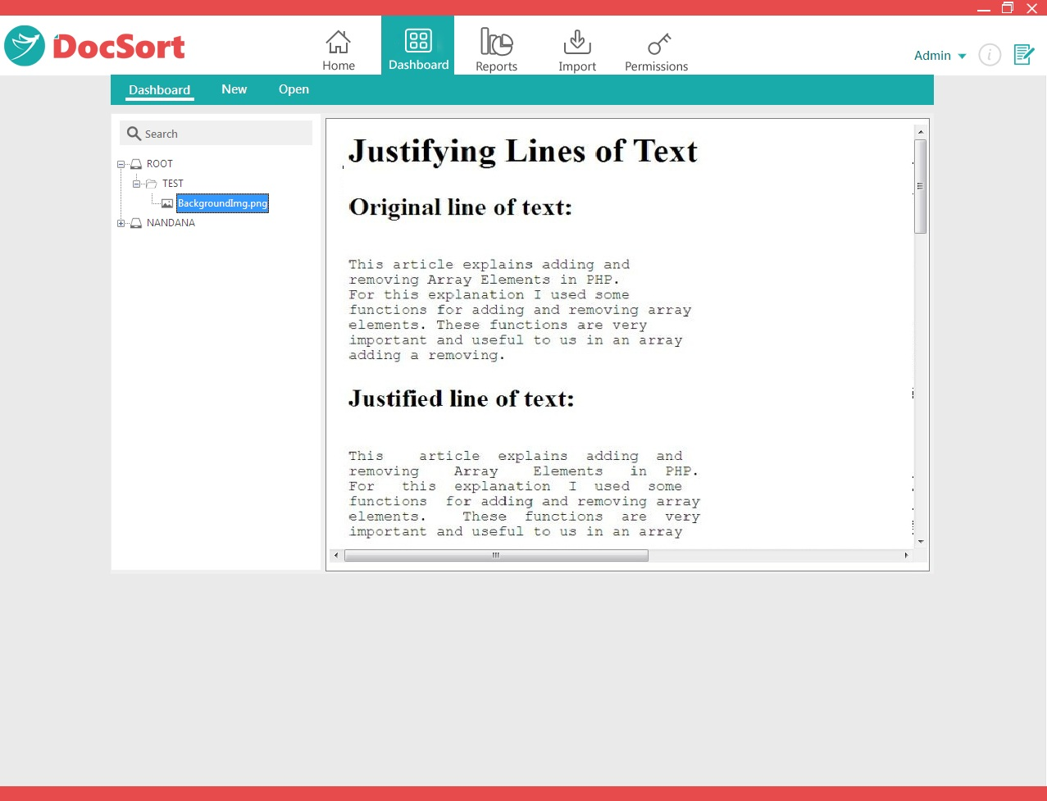

New:
You can create File Cabinets by clicking on New menu item of Dashboard Menu. The File Cabinet is the root node of the tree. You are able to expand or collapse the File Cabinet by clicking on the Plus symbol next to the icon.
The Tree view is located on the left side panel of DocSort . This displays the list of folders and documents in the File Cabinet. The tree view can be used for browsing a file cabinet as well as organizing the File Cabinet in folders. Most of the Tree view options are available by right clicking you mouse on a selected File Cabinet, folder, or document. Folder and Document details of File Cabinet are located on the right side of the panel of DocSort .
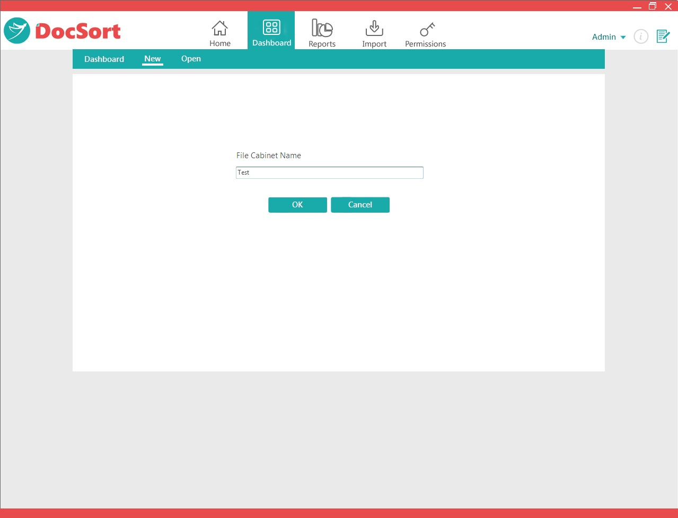
Here you can write any File Cabinet name and press OK button, will get the following screen.
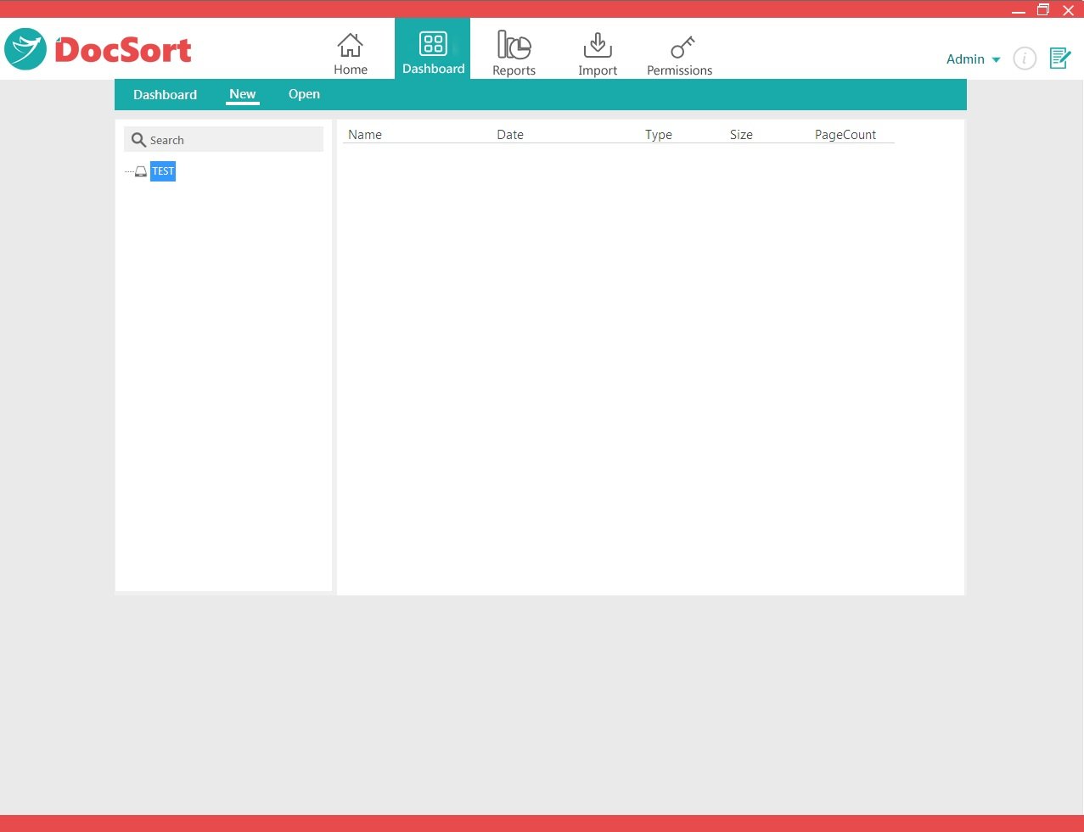

Right Click Options on File Cabinet
· | New Folder: Creates a new folder in the File Cabinet.
· | Expand: Will open all sub folders containing documents. This may take some processing time if the File Cabinet contains large amounts of folders.
· | Collapse All: Closes all open folders and the File Cabinet.
· | Import
o | Import Files: Import selected file(s) from the Windows file system to the File Cabinet root.

Right Click Options on selected Folder
· | New Folder: Creates a new folder in the File Cabinet. The folder will be highlighted to change the name.  Expand: Will open all subfolders contain documents.  Collapse: Closes all open subfolders and the selected folder.
· | Delete: Deletes the selected folder and its contents from the File Cabinet.
· | Rename: Make changes to the name of the selected folder.
· | Import
o | Import Files: Import selected file(s) from the Windows file system to the selected folder.

Right Click Options on selected File
· | Delete: Deletes the selected file from the File Cabinet.
· | Rename: Make changes to the name of the selected file.
· | Send to
o | Export: Copy selected file from tree view to the Windows file system selected folder.

Open:
You can also open the created File Cabinets, for this click on Dashboard → Open
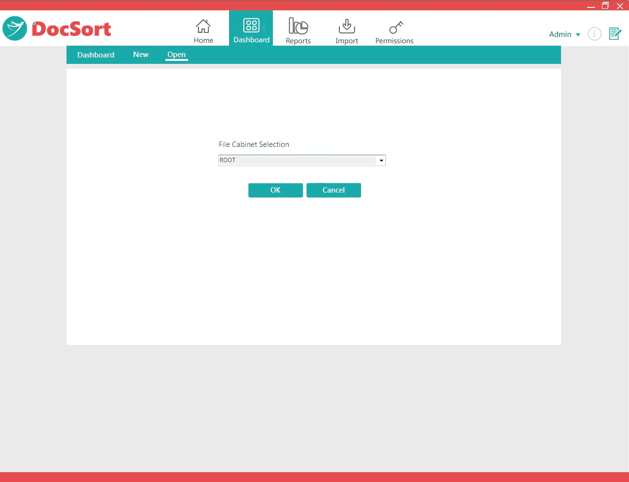
Select any of the File Cabinet and press Ok button, the screen shows below.
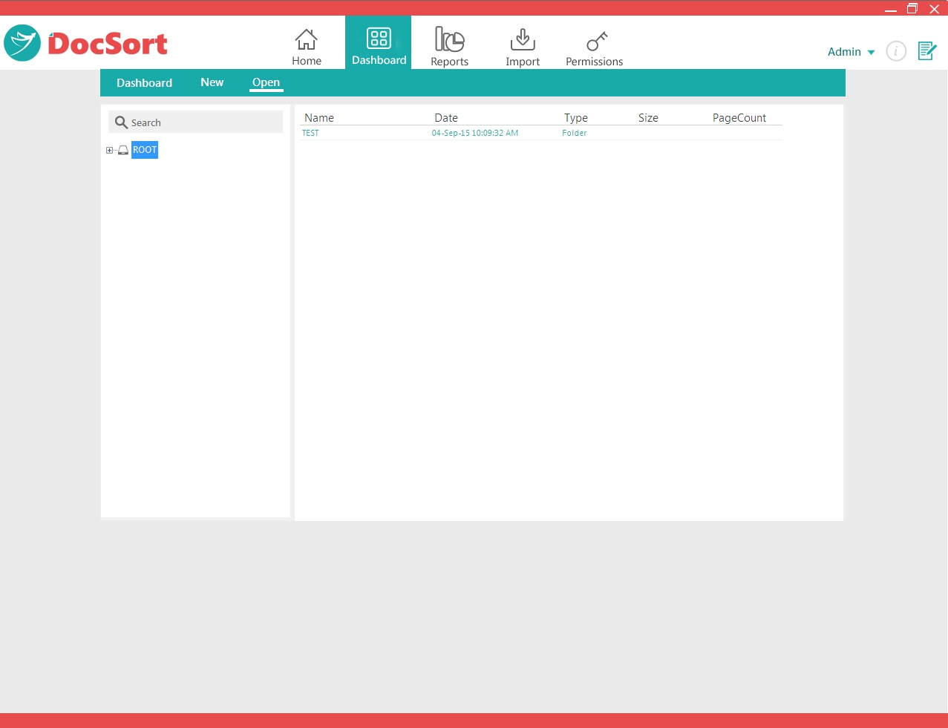

Let us make discussion on Reports Menu which includes the following features..
- Show Documents
- Documents Count
- Status Report
- Document Report

Show Documents:
This page will show us for a particular date and moved documents into the corresponding Destination folder. You can also view the moved document by clicking on View link of each document row, below are the screen shots for this. You can also have an option to search with Document Name.
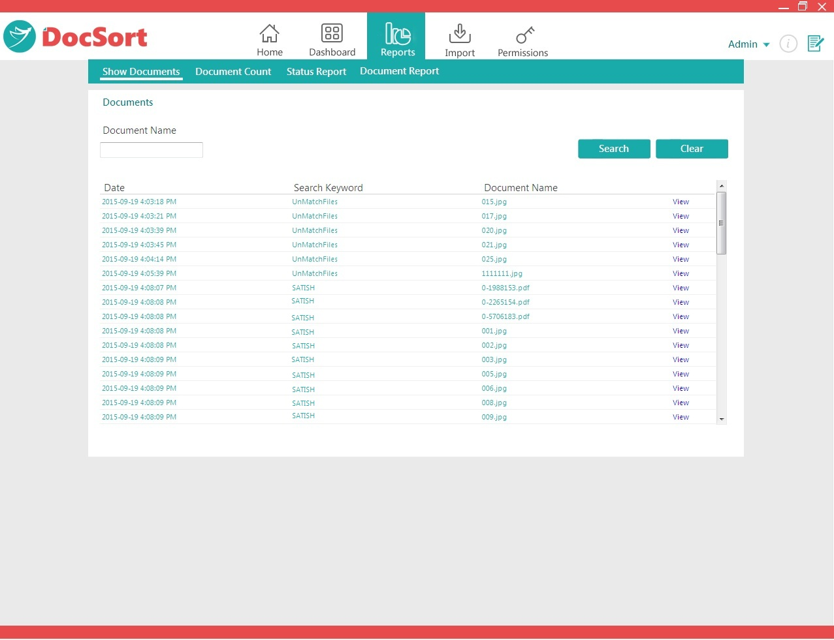
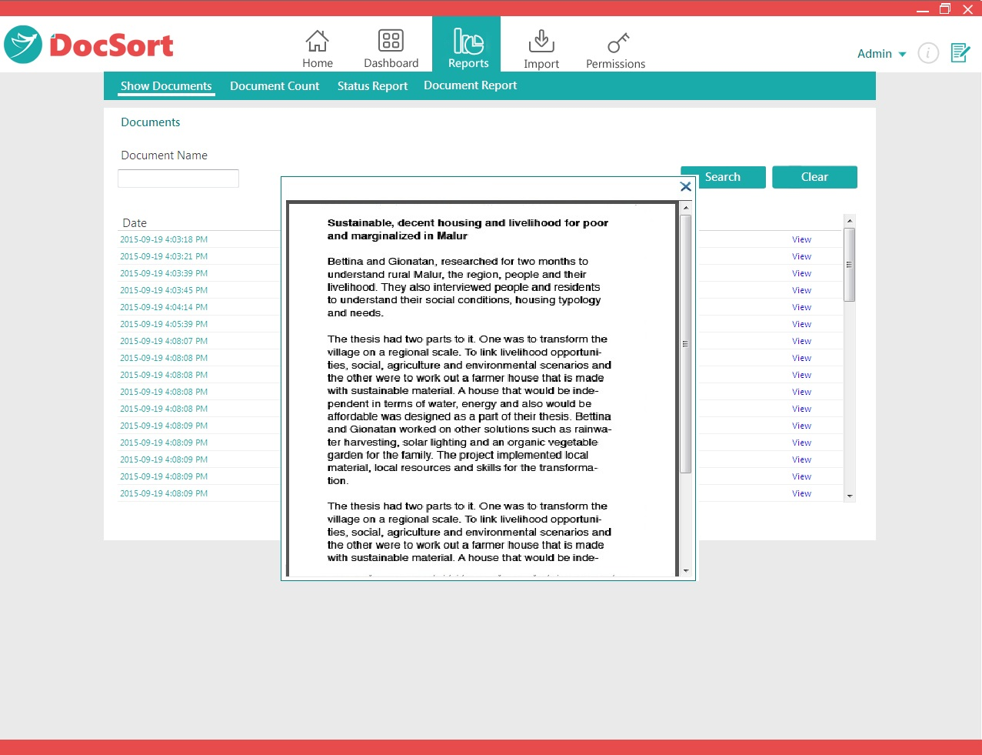

Documents Count Report:
This report will show us for particular dates like in-between Start Date and End Date, the count of documents present in Subfolder of Main folder. Here Keyword is Main folder and Subsection is Sub folder to that of Main folder.

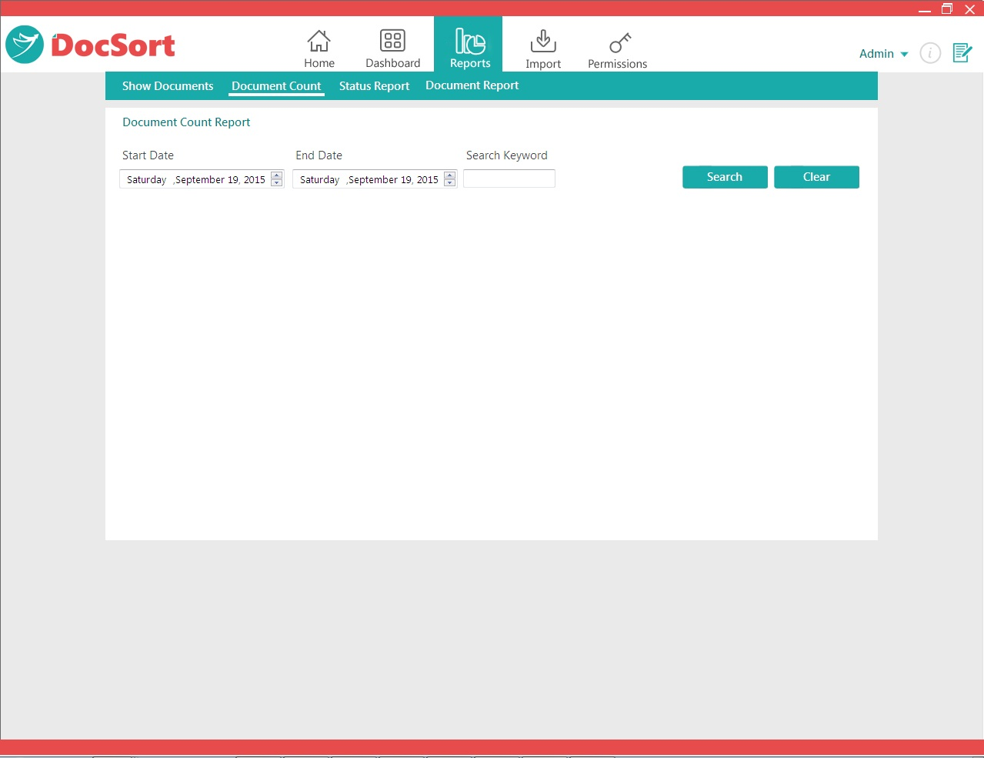
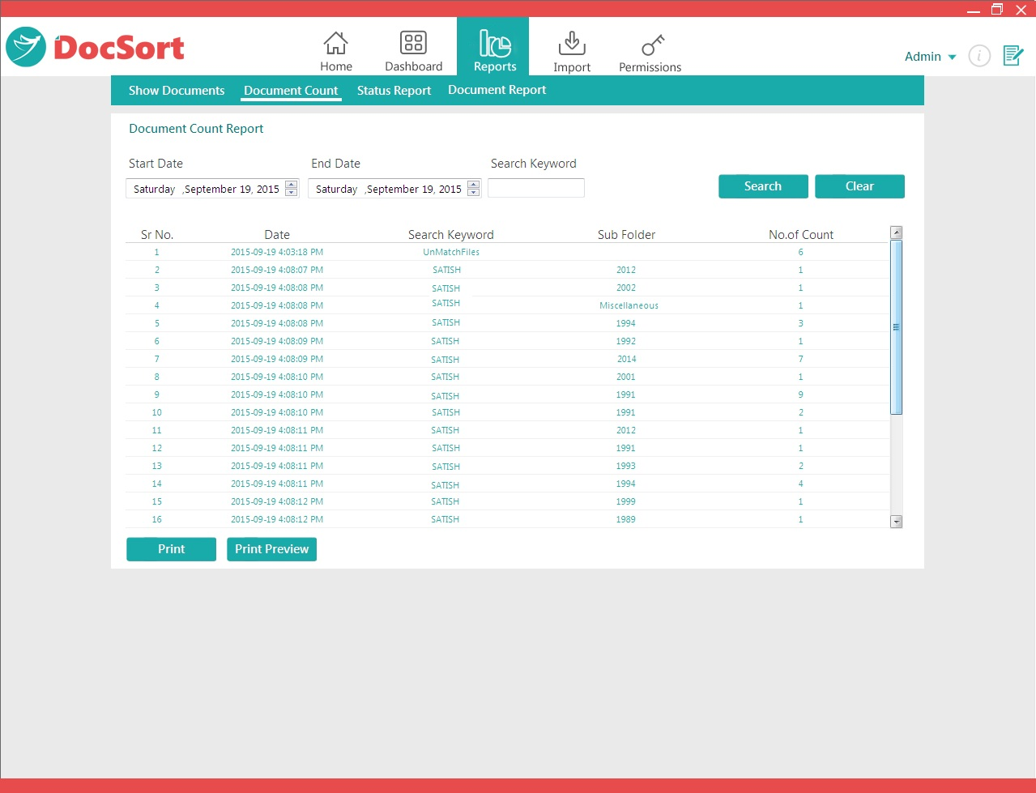

You can print and print preview the document count details

Documents Status Report:
This report will show us for particular dates like in-between Start Date and End Date the moved document list along with details. Below are the screen shots..

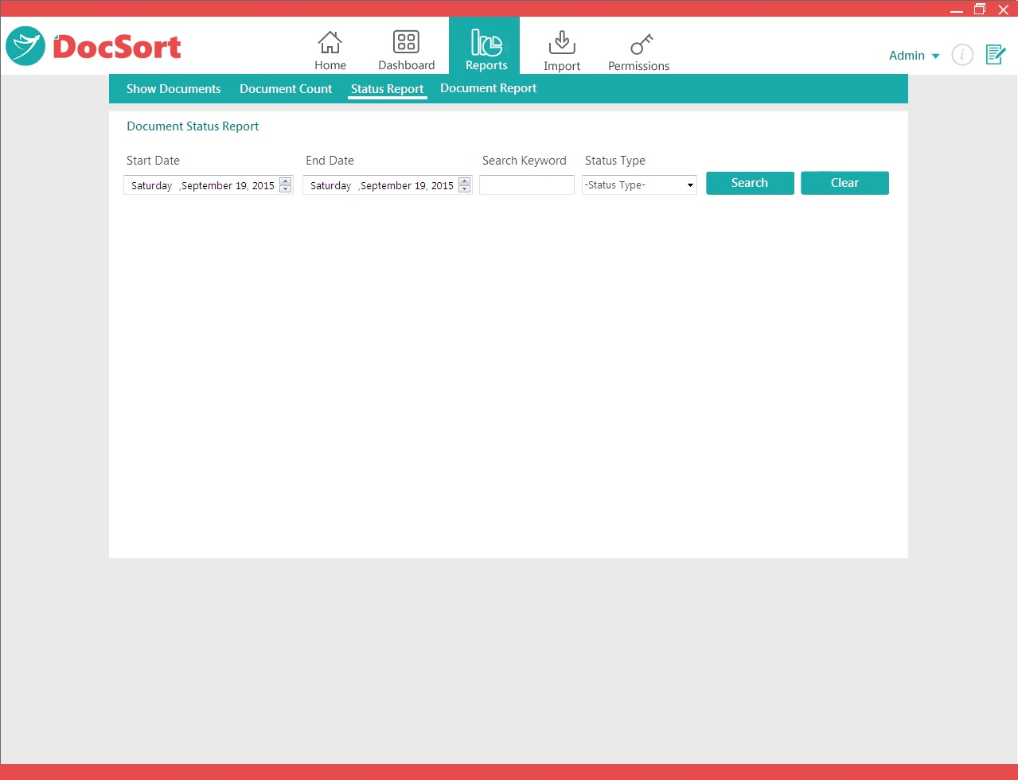
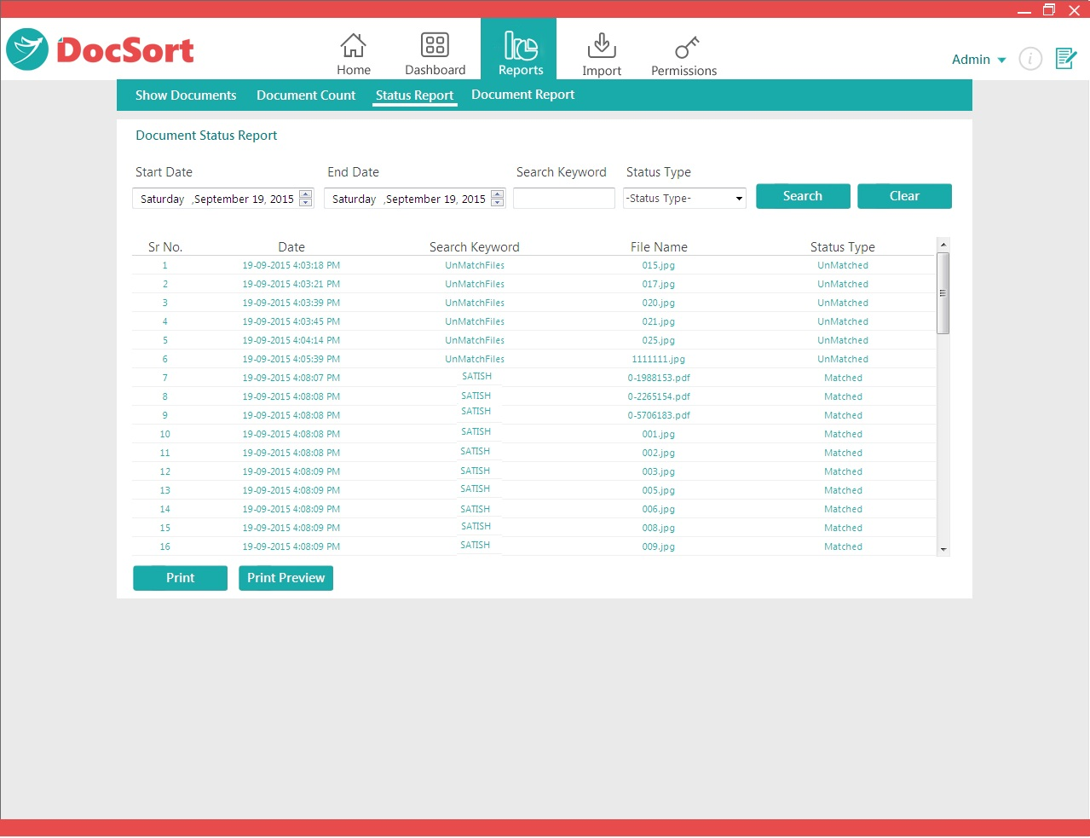

You can also have an option to search with Keyword as well as Type. Also you can print and print preview the moved document details.

Documents Report:
In this report you will know the count of Number of Documents used for scanning along with the matched count of documents also unmatched count of documents. You can also print and print preview the count of moved document details. Below are the screen shots.

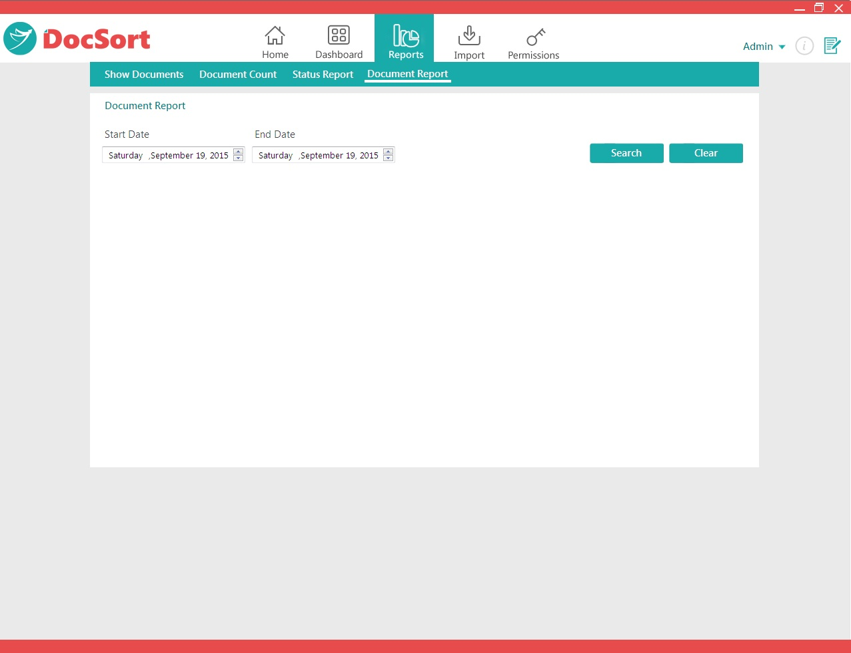
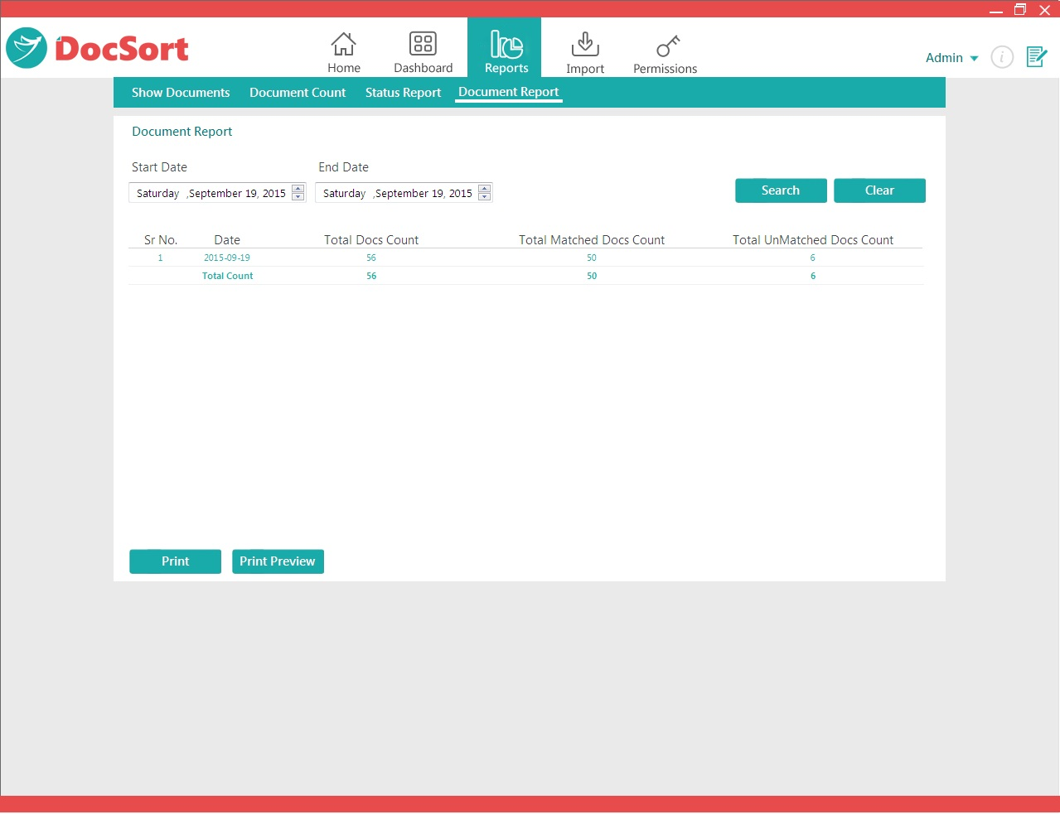

Main Menu pointer click contains Change Password , Log History and Logout features.
Change Password:
This feature is to change the password of the login user, here you can change the password by providing old password by replacement of this with the New password, press Submit button.

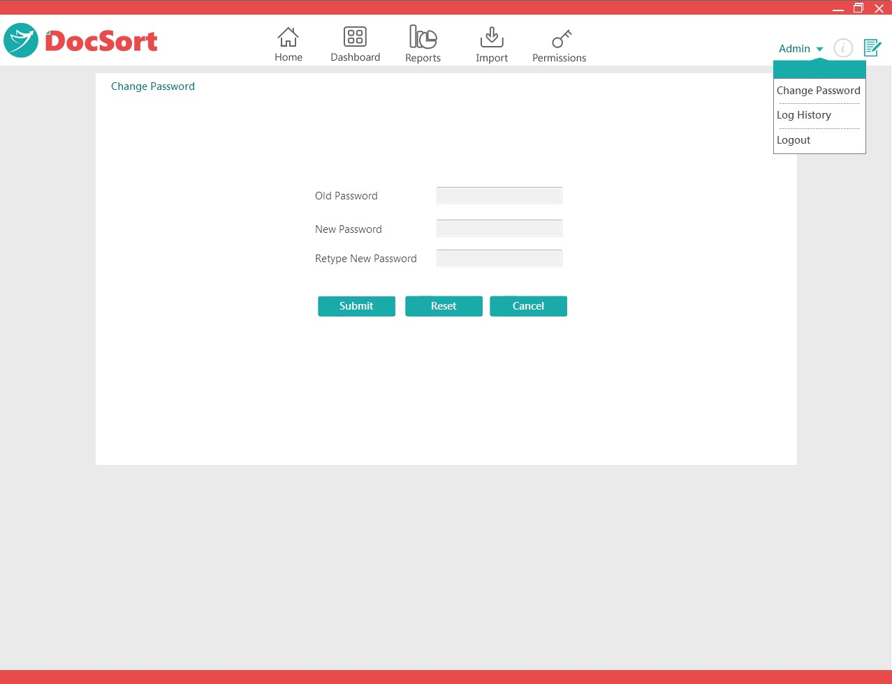
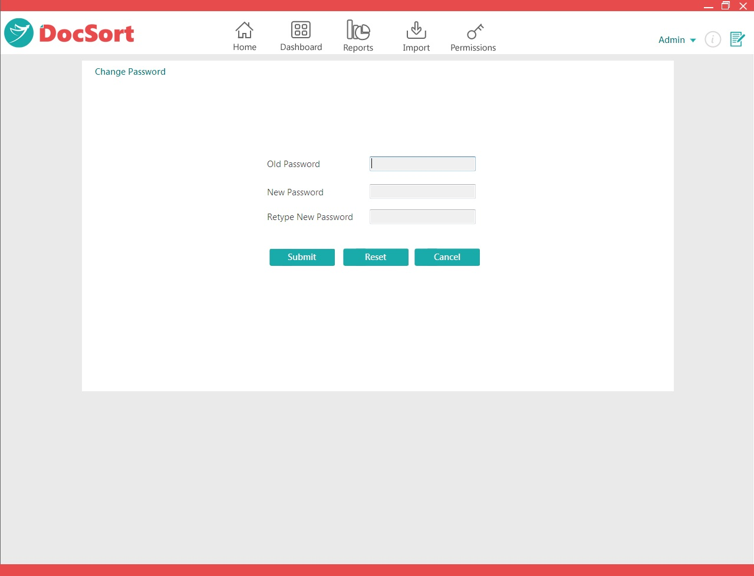

Log History:
This page will shows the details of the user login into the application along with Date and Time. You can also search the users who are logined into application with Today’s Date.

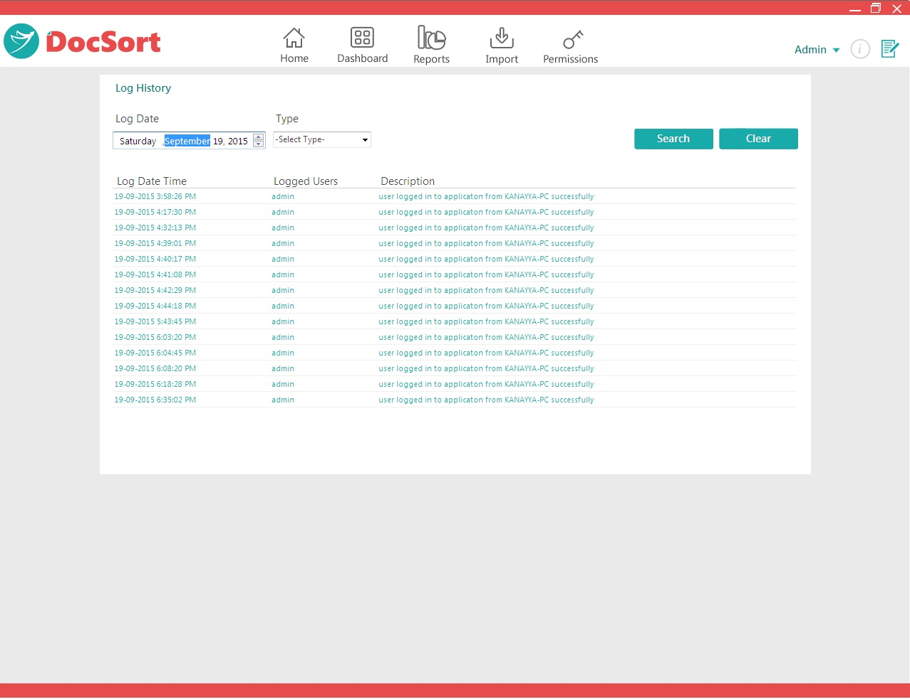

You can find Feedback page in the right corner of Main menu, this page is to give feedback on some of contents.

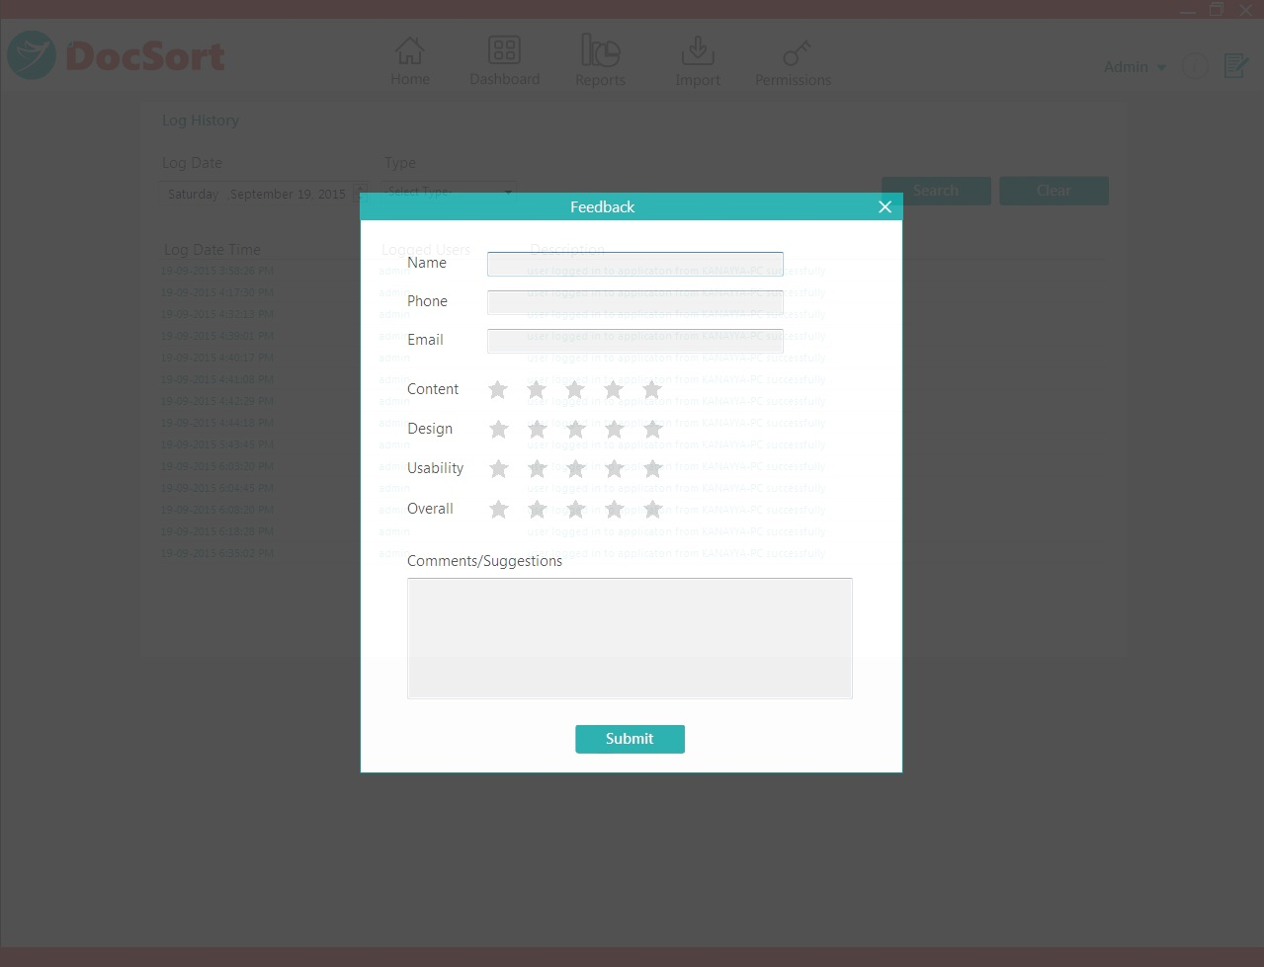

Also you can find Logout label on Main menu of Home Page.

